Topline conclusions:
The 1999 NIDA cocaine study, as a primary outcome of measurement, assessed days used in the past 30, measured at months 1-6 post treatment, as well as follow up at 9 and 12 months. My data analysis here uses only baseline and the first 6 months of treatment. They compared group drug counseling alone (GDC) to group drug counseling plus one of : individual drug counseling (IDC), cognitive therapy (CT) and supportive expression (SE).
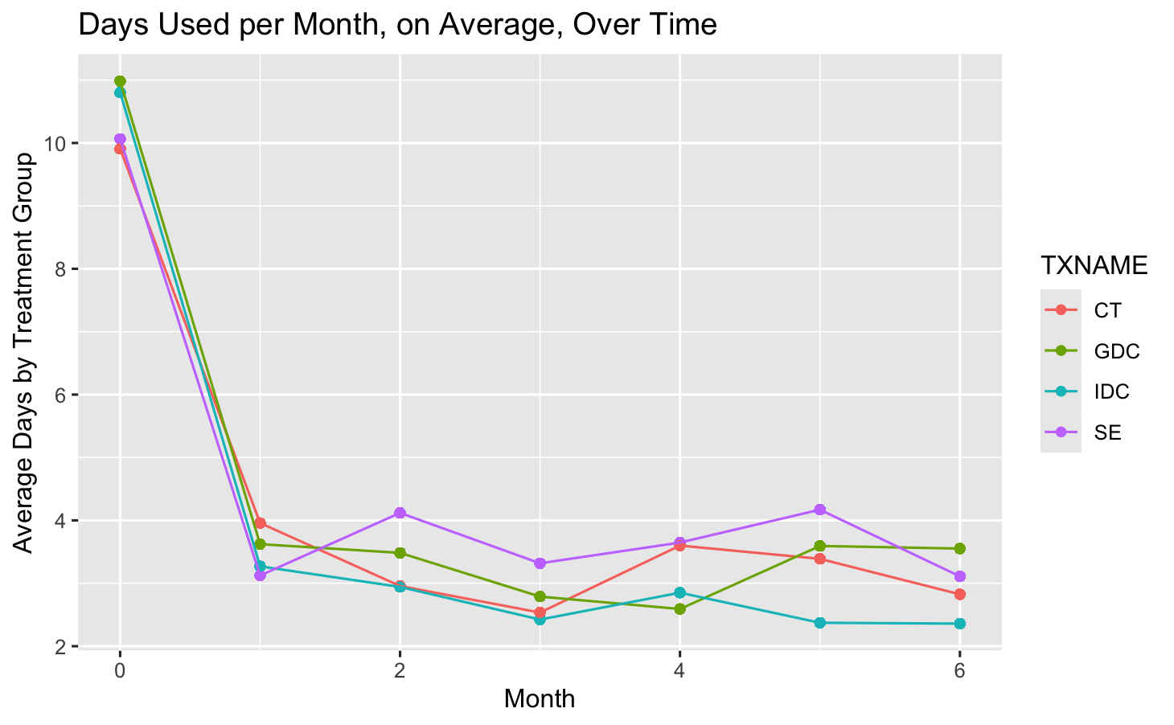
For all following analyses, I used piecewise time contrasts, as indicated above. This decision was data driven, by inspection of the mean profile plot. It is obvious that reported monthly use fell dramatically after intake (month 0). Therefore, I had two research questions: 1. Did the magnitude of the decline after any treatment differ by the type of treatment? 2. Was there any decline at all with continuing treatment past one month? Absent subject matter expertise to distinguish confounders, mediators, and colliders, I used no covariates, using only time, treatment, and site as fixed effects.
 | Trend (Latent Scale)
TXNAME | Beta binomial | Beta | LMM
CT | -1.74 | -1.37 | -0.987
GDC | -2.17 | -1.67 | -1.235
IDC | -2.36 | -1.78 | -1.3
SE | -1.83 | -1.4 | -1.099

All of these models use latent scales for estimates on these trends over time, that render raw numbers to answer these research questions uninterpretable. That said, differences within a model can be interpreted. All models found significant decreases in drug use after any treatment. All models found IDC to be the best treatment, followed by GDC, SE, with CT being the worst, though still improving. The only significant pairwise contrast across models was that IDC was significantly better than CT at reducing drug use after a single month of therapy (95% CI: 0.0394 ,1.1762)
Overall Change After Additional Treatment
Model | Estimate | Lower CL | Upper CL
Beta binomial | -0.0974 | -0.141 | -0.0566
Beta | -0.0449 | -0.0678 | -0.021
LMM | -0.03 | -0.0455 | -0.0142

For the second research question, all three models found overall significant declines in use following additional therapy. None, however, found any significant differences between treatments. That said, for GDC and SE across all models, 95% credible intervals included 0, while for IDC and CT, they did not include 0. Therefore, while we can’t conclude that any treatment did better than any other at decreasing use, we can only conclude that IDC and CT reduced use with additional treatment.

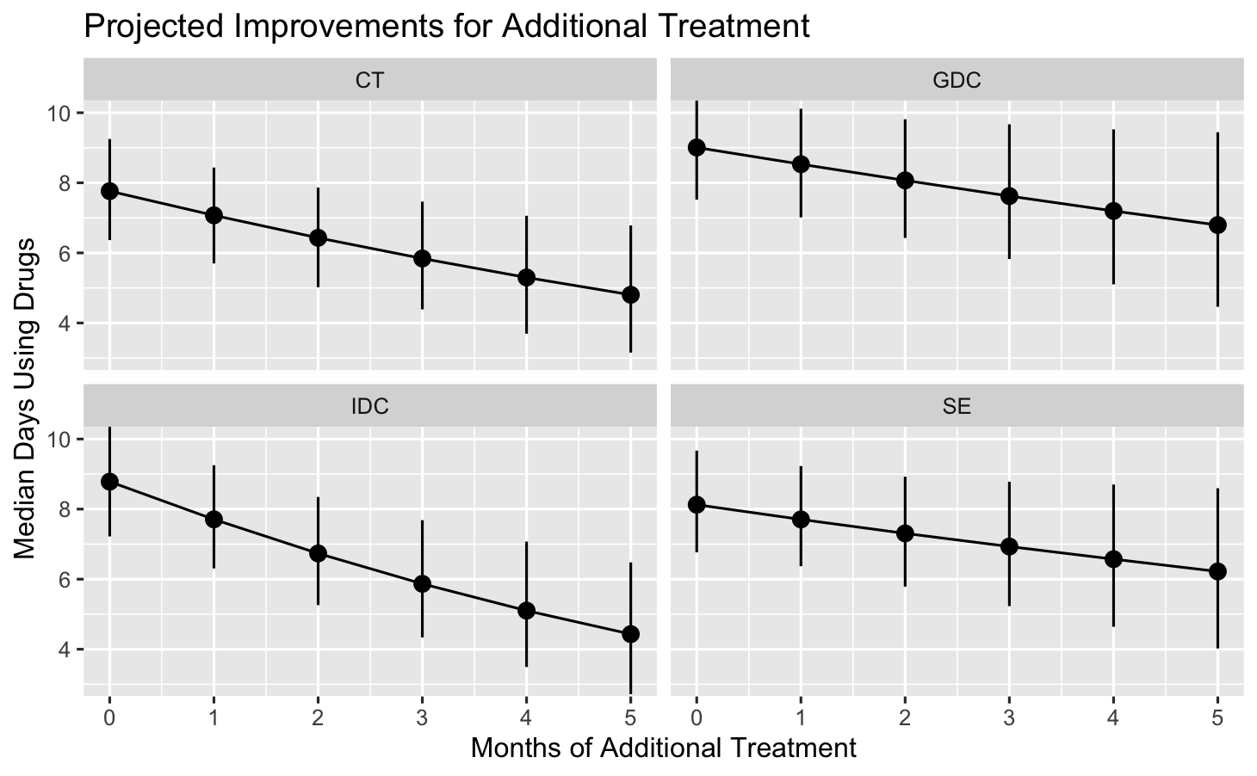
This visualization demonstrates for the primary model, the estimated declines over time. Increasing uncertainty over time is partially due to dropout, but mostly due to the model automatically increasing certainty as values approach 0. Visually, it does seem as though IDC has the strongest slope. I excluded baseline here as it would only compress the scale, and the second research question pertains solely to whether additional therapy past one month reduced use. Note that these values pertain to the theoretical median patient, not to the population average, and so are larger than the numbers seen in the mean profile plots above.

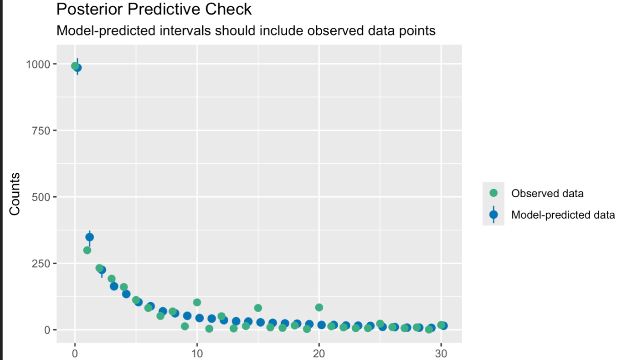

These are the conclusions, but how does the primary model perform overall? First, I can do a posterior predictive check, which checks whether data predicted by the model is similar to the observed data, in the aggregate. In the above visualization, the x axis is the number of predicted days using drugs, and the y axis is the number of observations with said number. The model appears to predict the data extremely well, It slightly underestimates the number of patients reporting 1 day per month, but correctly the number of 0s and 30s, which can be a huge issue for these models, meaning no extra sub-models need to be fit for 0s. The other potential issue is that it cannot predict the spikes at 10, 15, 20, and 25 days reported, which is likely due to inaccurate recall. No model can really account for that, however.

Technical Details:
At the time, the researchers used a ln(y +1) transformation on the days used per month data, followed by a linear mixed model anova (MMANOVA) analysis using categorical time and a Toeplitz covariance structure, adjusting for baseline use, in SAS’s PROC MIXED. The Box Cox transformation has many issues, and the use of categorical time alone loses much statistical power as it discards the time ordering of the data. In addition, the Normal distribution knows no bounds, and wherever the transformation of zero has landed, the model will predict values lower than transformed zero, which is nonsensical.
As sensitivity analysis, I fit three distributional families with the same random effect structure. For all three, for each patient, I fit random intercepts as well as random slopes to the two time contrasts, as well as residual first order autocorrelation to capture nonlinear within-subject trends. The restricted fixed effect selection means that The limited fixed effect selection causes random intercepts to reflect variation at intake. The data my professor gave me did not contain therapist level data, and I treated site as a fixed effect with no interaction, due to the small number (n = 5). First, I fit a beta binomial model, treating each day as a “trial”, which maintained the discrete and bounded nature of the data. Second, a shifted beta model, where 0s were set to 0.01, 30s to 30.1, and all data divided by 30.02, to fit the data to the exclusive (0,1) bounds of beta regression. Third, I used the same ln(y+1) transformation to the data and fit a linear mixed model (LMM). The beta and beta binomial models used the complementary log-log (cloglog) link due to the highly skewed point mass of the observations, while the LMM used the canonical identity link.
I used the flexible Bayesian regression package brms in R to perform this analysis, as it’s use of priors for random effects allows all prespecified random effects to converge, unlike frequentist models. I used default priors for all effects, which were weakly informative for random effects and flat for fixed effects. Thus, the credible intervals presented are asymptotically equivalent to restricted maximum likelihood estimates. Given the large subject count (n = 487) and total observations (N = 2683), this asymptotic assumption should hold. I used the emmeans package to estimate time trends and contrasts, equivalent to SAS’s LSMEANS and ESTIMATE statements.
Abstracting from the 'trials' interpretation, the beta-binomial, which was treated as the primary model, serves as a flexible distribution for discrete bounded data [0,30], accommodating both the bounded support and the observed dispersion patterns. The estimated precision parameter (φ = 116 [57, 251]) indicates the distribution is well-behaved with no pathological boundary issues.

For all random effects except the PostTreatTime slopes in the Beta and LMM, the lower credible interval is meaningfully different than 0, indicating that the sample participants meaningfully differed in their baseline use and response to treatment, conditional on residual correlation. For all three models, residual autocorrelation was positive and credibly different from 0, indicating that conditional on individual level characteristics, there was still correlation on the population level among measurements.

